BSc Computer Science Module: CM3040 Physical Computing and Internet-of-Things (IoT) Final Report & IoT Project

Topic: IoT for Memory and Cognitive Development in Children

From Justin Ng Kwan Wei
SIM ID: 10261713
UP ID: 240662170

Contents
Abstract 4
Background Research 5
Importance of Memory and Cognitive Development in Growing Children 5
Using IoT devices to address memory and cognitive development 5
Comparison with Existing IoT-Based Solutions 6
Project Specifications 7
The System 7
Primary Target 7
How it Works 7
Advantages of the Proposed System 8
System Architecture and Project Infrastructure 9
System Design Documentation 9
Idle State (Difficulty Selection) 9
Show Sequence State 9
User Input State 10
Game Over State 10
State Diagram 11
System Design Architecture and Requirements 12
Software Tools and Development Environment (System Requirements) 12
Arduino IDE (ESP8266 Arduino Core) 12
Node-RED (Dashboard + Data Processing) 12
painlessMesh (Mesh Networking Library) 12
System Architecture Diagram 13
Data flow diagram 13
Circuit Diagrams 14
Board Table 14
Indicative test plan 15
System Requirements 15
Functional Requirements 15
Non-Functional Requirements 15
Testing Strategy and Evaluation 16
Testing was carried out to ensure that the system components, software, and network function reliably. 16
1. Hardware Testing 16
2. Software / Game Logic Testing 17
3. IoT / Network and Dashboard Testing 17
4. User Testing 18
5. Unit Testing 19
System Implementation 21
Critical analysis and reflection 25
References: 26

Abstract
This report presents the development and evaluation of an IoT-enabled Simon Says memory game designed to support memory and cognitive development in children. The system was implemented using an ESP8266-based microcontroller and integrates physical computing components including LEDs, push buttons, and an LCD display to deliver interactive sequence-based gameplay.
The device incorporates IoT functionality through a web-based dashboard, enabling real-time monitoring of gameplay performance such as selected difficulty level, score, and time taken. Communication between the device and dashboard was achieved using REST-based HTTP requests with JSON-formatted data.
Comprehensive testing was conducted across hardware, software, and network components to ensure reliable operation and compliance with defined functional and non-functional requirements. The final system demonstrates the feasibility of combining physical interaction with networked data monitoring to create an engaging, data-driven cognitive learning tool.

Background Research

Importance of Memory and Cognitive Development in Growing Children
Memory plays a fundamental role in children’s learning and overall cognitive development [1]. The ability to encode, retain, and recall information directly influences academic performance, problem-solving ability, language acquisition, and decision-making processes.
During early childhood, these cognitive functions are still developing [1]. Children may struggle with sustained attention, concentration, and effective information retention, which can affect their engagement and learning outcomes. Establishing a strong foundation in memory and attention control at this stage is therefore essential to support long-term academic achievement and progressive cognitive development[2].

Using IoT devices to address memory and cognitive development
Physical computing and Internet of Things (IoT) devices offer a promising approach to addressing cognitive development challenges. By integrating tangible interaction with digital processing, interactive learning environments can be developed that encourage engagement through physical input, visual cues, and auditory feedback. This multimodal interaction promotes sustained attention and strengthens memory retention.
Beyond interactive gameplay, IoT-enabled devices support real-time performance tracking and data collection. This enables educators and caregivers to monitor learning progress, identify areas of difficulty, and adjust challenge levels accordingly. Such systems can be implemented in home and educational environments, supporting independent practice, collaborative activities, and personalised learning experiences.

Comparison with Existing IoT-Based Solutions
Several IoT-based solutions aim to improve memory and cognitive development in children. A common approach is mobile and tablet-based applications [3] that provide interactive visual and auditory exercises targeting memory, attention, and problem-solving skills. These applications typically use cloud-based databases and adaptive algorithms to adjust difficulty based on user performance, allowing personalized learning experiences. While this enables scalability and real-time feedback, such systems rely heavily on prolonged screen exposure and continuous internet connectivity, which may raise concerns regarding reduced physical interaction, potential overexposure to screens, and data privacy risks.
Another category includes smart educational toys [4] designed to promote cognitive development through physical engagement. These devices often integrate embedded microcontrollers and sensor arrays (e.g., touch, motion, or light sensors) to detect user interaction and trigger responsive feedback such as sounds or visual cues. Although these systems encourage hands-on learning and reduce screen dependency, many operate as closed architectures with limited customization and minimal cloud integration. As a result, they often lack long-term progress tracking, performance analytics, and remote monitoring capabilities for caregivers or educators.
Overall, existing solutions tend to emphasize either digital adaptability or physical interaction, but rarely integrate both effectively. This creates a gap for systems that combine customizable physical engagement with transparent performance monitoring and scalable data management.
Existing IoT-Based Solutions | Project Proposal
Heavy reliance on prolonged screen-based interaction. | Reduced screen dependency through sensor-driven physical interaction.
Closed-system architectures with limited scalability and customization. | Modular and customizable system with adjustable difficulty and configurable features.
Limited performance analytics and minimal caregiver data transparency. | Integrated performance tracking with accessible data visualization for caregivers/educators.

Project Specifications

The System
The proposed solution is an IoT-enabled, Arduino-based Simon Says memory game designed to support memory and cognitive development in children. An ESP-based microcontroller controls LEDs and an LCD display to generate memory sequences, while users interact by observing, memorising, and replicating the patterns using physical push buttons.

Primary Target
The target users are children in early primary education, to strengthen foundational cognitive skills such as memory retention, attention, and pattern recognition through physical interaction and visual cues. The system is suitable as a supplementary learning tool in primary schools, enrichment programmes, or home-learning environments. Its interactive and game-based format encourages active participation, making cognitive training engaging rather than instructional.

How it Works
The system operates using a state-based game model consisting of Idle, Show Sequence, User Input, and Game Over states. When the start button is pressed, a random LED sequence is generated and displayed through coloured light patterns. The user must observe the sequence and reproduce it by pressing the corresponding buttons in the correct order.
Correct input results in progression to the next round, where the sequence length increases, gradually raising memory demand. Incorrect input immediately transitions the game to the Game Over state, where score and time taken are recorded and transmitted to the web dashboard.
To accommodate different cognitive ability levels, the game includes selectable difficulty settings: Easy, Normal, Hard, and Very Hard. Each difficulty adjusts the LED blink duration and the interval between flashes. Easier levels provide longer illumination and slower pacing, while harder levels reduce the flash duration and pause intervals, requiring faster processing speed from the player.
Gameplay data, including score, time taken, and session history, is transmitted to the dashboard via REST-based HTTP requests using JSON formatting, enabling real-time monitoring and post-session analysis.

Advantages of the Proposed System
Compared to screen-based memory applications, this solution reduces prolonged screen exposure while promoting active, hands-on interaction. Physical buttons and visual LED cues enhance engagement and hand-eye coordination, supporting experiential learning rather than passive screen-based interaction.
Unlike traditional Simon Says toys with fixed pacing and no data tracking, this system offers adjustable difficulty levels, progressive scaling, and IoT-enabled performance monitoring. Educators and caregivers can configure difficulty settings and review historical performance data, allowing cognitive challenges to be tailored to individual learning needs.
By integrating interactive physical gameplay with real-time performance analytics, the system moves beyond a simple memory toy and becomes a structured, data-informed learning tool.

System Architecture and Project Infrastructure

System Design Documentation
The proposed system adopts a state-based architecture consisting of four primary states: Idle (Difficulty Selection), Show Sequence, User Input, and Game Over. Each state defines specific behavioural rules, input mappings, and transition conditions to ensure deterministic system operation.

Idle State (Difficulty Selection)
The Idle state functions as the default state upon power-up and after the completion of a game session. In this state, the system allows users to select a difficulty level prior to initiating gameplay. The selected difficulty determines LED playback timing parameters.
The four coloured buttons correspond to difficulty selection as follows:
Colour | Difficulty | Light Duration (ms) | Interval (ms)
Blue | Easy | 700 | 400
Yellow | Normal | 600 | 350
Red | Hard | 500 | 300
Green | Very Hard | 400 | 250

Upon system startup, the default difficulty level is set to Easy. The LCD display indicates the currently selected difficulty and prompts the user to press the Start button to begin the game.
When a difficulty button is pressed, the system updates the selected mode and refreshes the LCD display accordingly. The game only begins when the Start button is pressed, at which point the selected difficulty parameters (LED blink duration and interval timing) are applied.

Show Sequence State
When the Start button is pressed, the system transitions to the Show Sequence state. In this state, a random LED sequence is generated and displayed to the user. The sequence is presented through controlled LED illumination patterns.
The selected difficulty level determines:
- LED illumination duration
- Interval between LED flashes
Higher difficulty levels reduce illumination time and inter-flash intervals, increasing cognitive load and processing speed requirements.
After the sequence playback is completed, the system transitions to the User Input state.

User Input State
In the User Input state, the system captures button presses from the user and validates them sequentially against the generated LED sequence.
If the user inputs the correct sequence:
- The sequence length increases by one.
- The retry counter resets to the maximum value defined by the selected difficulty.
- The system transitions back to the Show Sequence state for the next round.
If an incorrect input is detected:
- The system immediately triggers a buzzer to indicate an error.
- The retry counter is decremented by one.
If the retry counter remains greater than zero:
- The system replays the same sequence.
- The user is allowed to attempt the same round again without increasing sequence length.
If the retry counter reaches zero, or if the user presses the Start/Reset button during gameplay:
- The system immediately transitions to the Game Over state.
- The current score and total time elapsed are finalised.
- Session data is recorded and transmitted to the dashboard via REST-based communication.

Game Over State
In the Game Over state:
- The final score and total time taken are recorded.
- Game data is transmitted to the web dashboard via REST-based HTTP requests using JSON formatting.
- The LCD displays the final score.
After completion, the system returns to the Idle state, allowing a new difficulty to be selected.

State Diagram
The state diagram illustrates how the system operates through a sequence of state transitions.

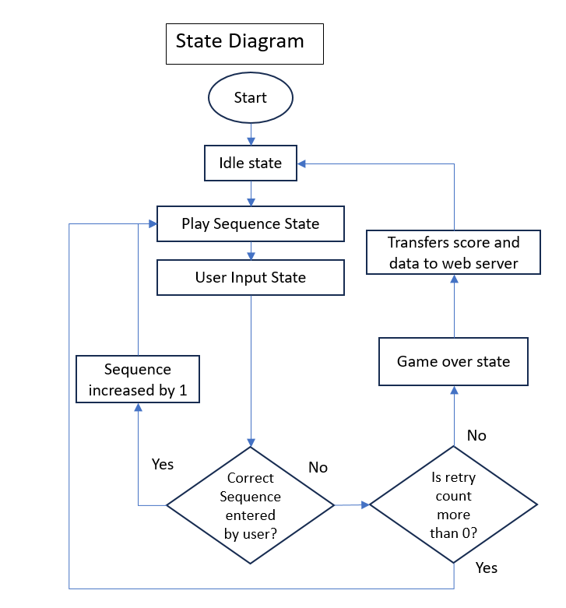

System Design Architecture and Requirements

Software Tools and Development Environment (System Requirements)
The project was developed using the following software tools and libraries to support firmware development, networking, dashboard integration, and deployment.
Arduino IDE (ESP8266 Arduino Core)
Arduino IDE was used to write, compile, and upload firmware to the ESP8266 microcontroller(s). It enables the implementation of the state-based game logic, LED and LCD control, button input handling, and network communication functions.

Node-RED (Dashboard + Data Processing)
Node-RED was used to build a web-based dashboard to visualise system status and gameplay performance (e.g., selected difficulty, score, time taken, and run history). It also acts as a lightweight integration layer to receive incoming device data (e.g., JSON messages), process and format it, and display it through a browser-accessible UI.

painlessMesh (Mesh Networking Library)
The painlessMesh library was used to enable communication between ESP8266 nodes without relying on a single access point. This supports distributed device coordination and messaging (e.g., sharing game state updates or session results) across multiple boards.

System Architecture Diagram
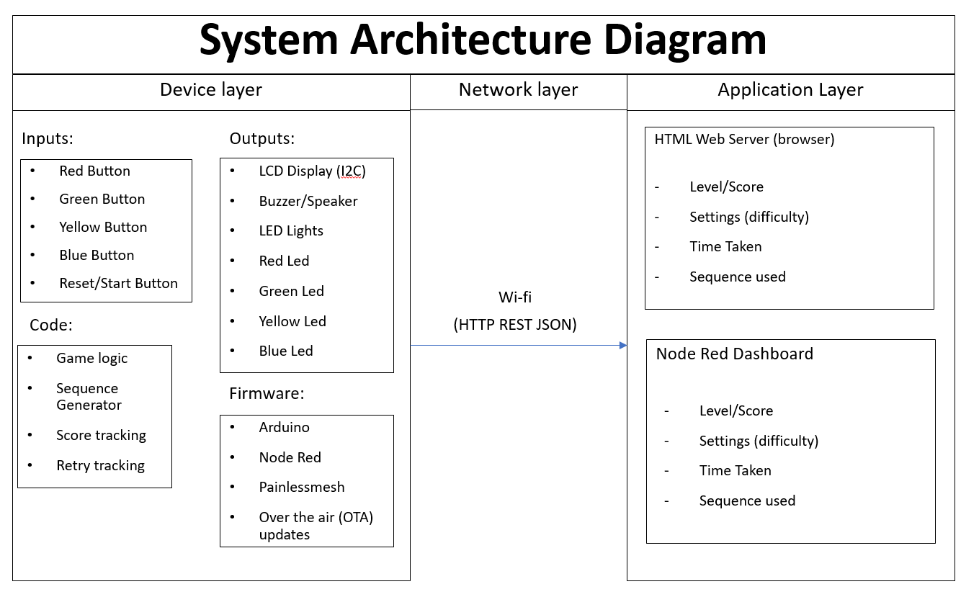

Data flow diagram
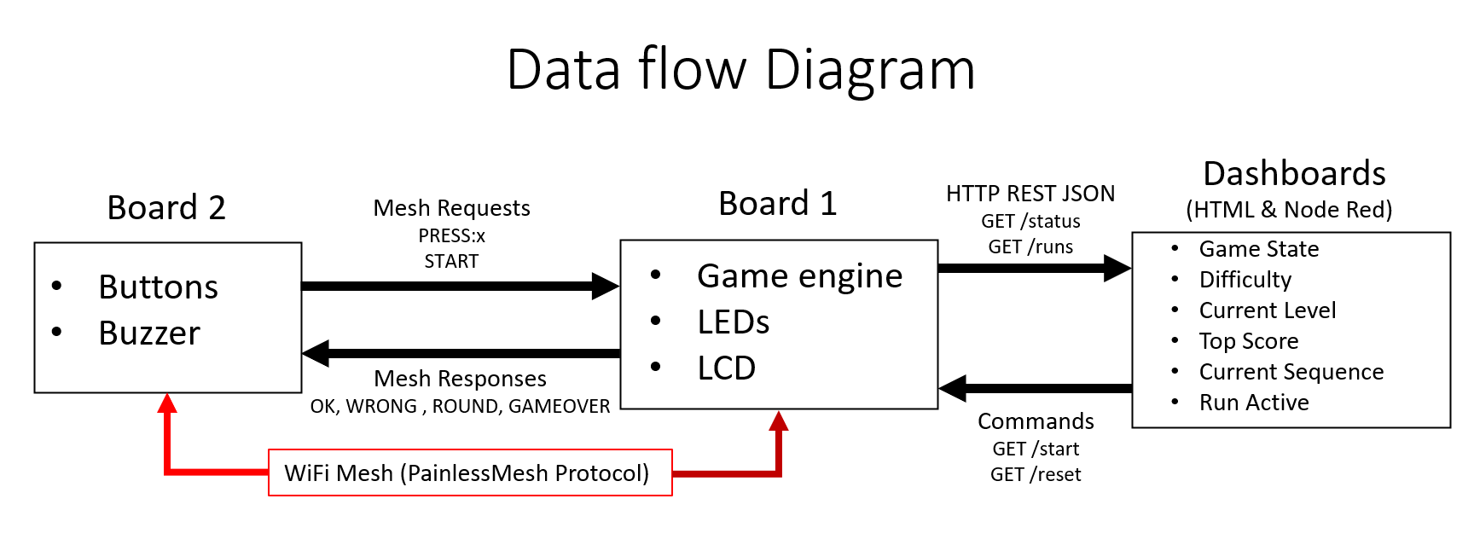

Circuit Diagrams
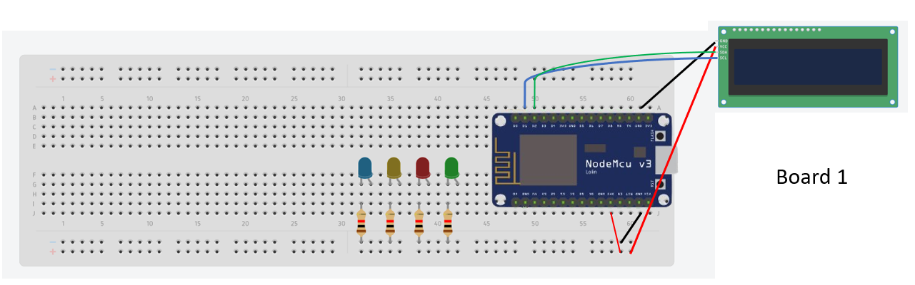
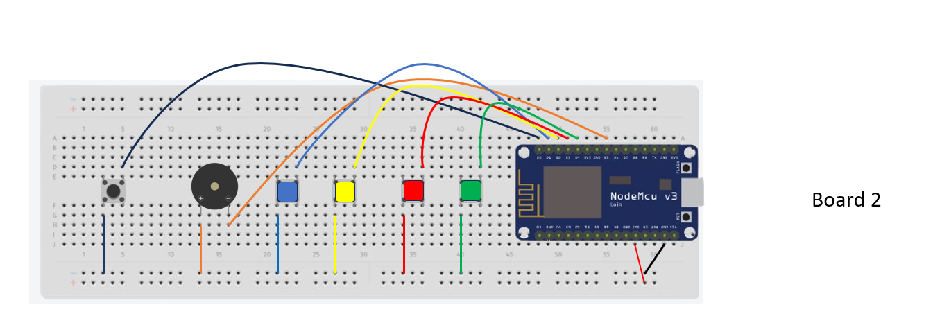

Board Table
Board | Port(s) | Connected to
1 | D5 | Blue LED (1 kΩ)
1 | D6 | Yellow LED (10 kΩ)
1 | D7 | Red LED (10 kΩ)
1 | D8 | Green LED (1 kΩ)
1 | D1, D2, GND, VIN, | LCD
1 | 3V3 | 3.3V Power
1 | GND | Ground
2 | D6 | Buzzer
2 | D0 | Start/Restart Button
2 | D1 | Blue Button
2 | D2 | Yellow Button
2 | D3 | Red Button
2 | D4 | Green Button
2 | 3V3 | 3.3V Power
2 | GND | Ground

Indicative test plan

System Requirements
The functional requirements for the system are summarised below.

Functional Requirements
List | Requirement
Game start/reset | The system shall start a new game when the start/reset button is pressed from Idle.  The system shall cancel the current game and go to the game over state when the start/reset button is pressed during gameplay.
Random sequence generation & progression | The system shall generate a random pattern and increase difficulty each round only if the previous pattern is cleared.
Sequence playback | The system shall display the sequence to the user using LEDs. At the same time, the LCD text will indicate to the user to watch the sequence.
User input capture | The system shall detect each button press and map it to the correct colour/value.
Input validation | The system shall validate the user’s inputs step-by-step to ensure the user keys in the sequence in order.
Scoring and timing | The system shall calculate score based on the number of rounds successfully completed and track the total time taken.
LCD state feedback | The system shall display clear LCD messages for each state: Idle, Show Sequence, User Input, Game Over.
IoT dashboard + REST endpoints | The device shall send status and run data via REST JSON.
Run history | The system shall store and display recent runs on the dashboard for both Node Red and HTML.

Non-Functional Requirements
List | Requirement
Dashboard performance | Dashboard page load/refresh shall complete in under 2 seconds.
Network resilience | The device shall reconnect automatically if Wi-Fi is lost.
Response reliability | REST endpoints shall return valid JSON and a correct HTTP status during normal operation.
Input responsiveness | Ensure button presses to system recognition have a delay to prevent double-triggering.

Testing Strategy and Evaluation

Testing was carried out to ensure that the system components, software, and network function reliably.

1. Hardware Testing
Requirement | Test | Expected Result | Observed Result
Button mapping | Press each coloured button 10 times in the Idle state. | Correct button ID detected every time with no repeat presses. | All button presses were correctly detected with no repeated inputs as confirmed by the serial monitor output.
LED output | Trigger each LED individually via a simple test mode | The correct LED should light up every time. | Each LED illuminated correctly when triggered.
LCD messages | Trigger each game state  (Idle state, Sequence State, Input State, Game Over state) | LCD always shows the correct state message. | The LCD correctly displayed the appropriate message for each system state.
Buzzer | Trigger the Game Over state | The buzzer should make a noise. | The buzzer produced an audible tone when an incorrect input was detected.
Reset/start behaviour | Press Start/Reset in Idle or press again mid-game. | Confirm that pressing the reset button is able to restart or end the game depending on the state. | Pressing the Start/Reset button successfully triggered the Game Over state.  When pressed during Idle, the button started a new game.

2. Software / Game Logic Testing
Requirement | Test | Expected Result | Observed Result
Difficulty Selection | Trigger each coloured button in Idle state | LCD displays selected difficulty | LCD correctly displayed the selected difficulty for each button press.
State transitions | Play the game to trigger each state | Correct state transitions | System transitioned correctly between Idle, Sequence, Input and Game Over states.
Sequence growth | Complete 3 rounds successfully. | Sequence length becomes 4 | After 3 successful rounds, the sequence length increased to 4.
Input Failure | Fail to complete a round. | Game ends immediately | Incorrect button press triggered the Game Over state and buzzer.
Score calculation | Complete 4 rounds then fail | Final score recorded as 4. | System recorded a final score of 4 after the incorrect input.

3. IoT / Network and Dashboard Testing
Requirement | Test | Expected Result | Observed Result
Wi-Fi connection test | Disconnect and reconnect Wi-Fi during operation | Device reconnects automatically without restart | When Wi-Fi was disconnected and reconnected, the device automatically restored the connection and resumed data transmission to the dashboard.
Dashboard refresh time | Refresh dashboard during and after gameplay | Dashboard loads within 2 seconds for both HTML and Node Red. | Both HTML and Node-RED dashboards refreshed within approximately 1–2 seconds and displayed updated session information correctly.

4. User Testing
Requirement | Test | Expected Result | Observed Result
Ease of difficulty selection | Ask user to select difficulty before starting | Majority of users correctly selected difficulty without assistance. | During testing, most users were able to select the desired difficulty level without assistance. Users were able to recognise the colour-coded difficulty buttons and proceed to start the game independently.
Clarity of LCD instructions | Observe whether user understands “Select Difficulty” and “Press Start” prompts | Users were able to follow instructions without confusion. | Users were able to understand the LCD instructions such as "Select Difficulty" and "Press Start" without additional explanation. No users reported confusion during the initial interaction.
Distinction between difficulty levels | Ask users to play Easy and Very Hard | Users reported noticeable difference in speed and challenge level. | When comparing Easy and Very Hard modes, users reported a noticeable difference in LED speed and overall difficulty, confirming that the difficulty scaling was clearly perceived.
Engagement level | Observe gameplay behaviour and collect feedback | Users remained engaged and attempted multiple rounds. | Users remained engaged throughout the gameplay session and attempted multiple rounds. Some users replayed the game several times to improve their score.

5. Unit Testing
Requirement | Test | Expected Result | Observed Result
Default difficulty setting | Power on the device | System initialises in Easy mode and LCD displays “Easy” as default difficulty | When the device was powered on, the system initialised in Easy mode and the LCD displayed “Easy” as the default difficulty setting.
Difficulty selection (Idle state) | Press Green/Red/Yellow/Blue before pressing Start | Selected difficulty updates correctly on LCD and internal variable | Pressing the coloured buttons (Green, Red, Yellow, Blue) correctly updated the selected difficulty on the LCD display and updated the internal difficulty variable.
LED playback timing | Measure LED interval for each difficulty | The LED illumination duration and interval should match the predefined difficulty parameters for Easy, Normal, Hard, and Very Hard modes. | The measured LED playback timings matched the predefined difficulty parameters. Easy mode used the longest illumination and interval timing, while Very Hard mode used the shortest timings, resulting in faster LED sequences.
Sequence generation | Start game and complete 3 correct rounds | Sequence length increases by 1 after each successful round | After each successful round, the sequence length increased by one, confirming that the sequence generation logic functioned correctly.
Input validation | Enter correct and incorrect sequences | Correct input progresses; incorrect input triggers buzzer | Correct button sequences allowed the game to continue to the next round, while incorrect inputs immediately triggered the buzzer and transitioned the system to the Game Over state.
Reset button during gameplay | Press Start/Reset button mid-game | System immediately transitions to Game Over state | Pressing the Start/Reset button during gameplay immediately terminated the session and transitioned the system to the Game Over state.
Score calculation | Complete 4 rounds then fail | Final score recorded as 4 | After completing four rounds and entering an incorrect sequence, the system correctly recorded the final score as 4.
Data transmission to dashboard | End a game session | Score and time taken successfully sent to Node-RED via HTTP JSON | At the end of the game session, the score and total time taken were successfully transmitted to the Node-RED dashboard via HTTP JSON.

System Implementation
This section displays the implementation of the project.
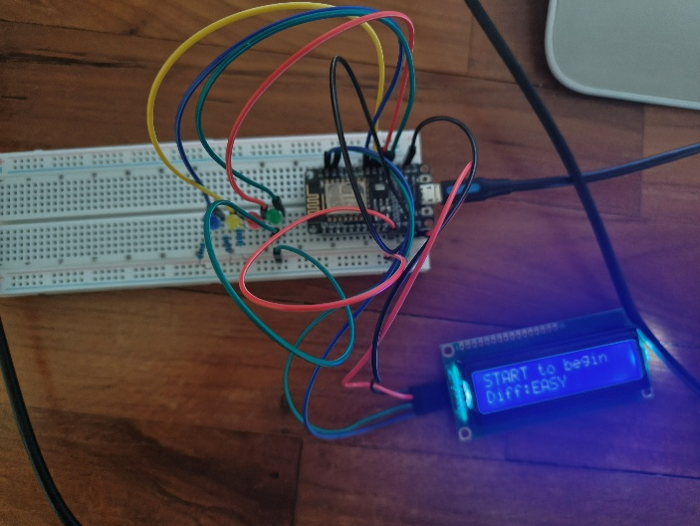
Figure 1: (Board 1) LED and LCD display.
The setup includes the ESP8266 microcontroller, LED indicators, push buttons,
and an LCD display used for gameplay feedback.
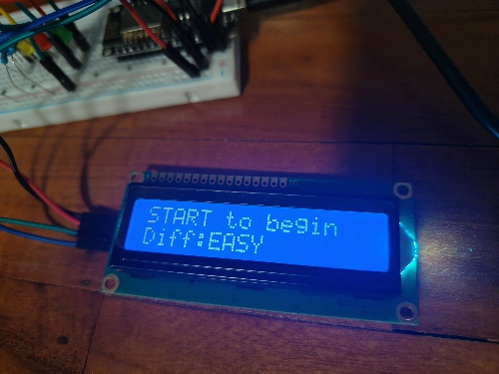
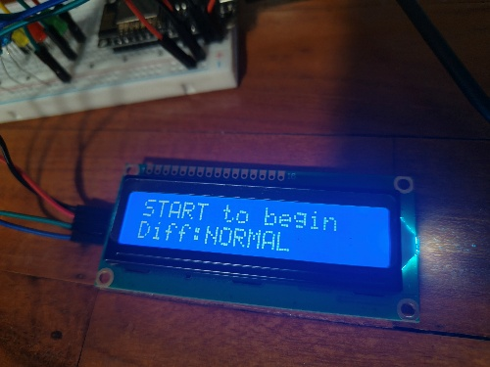

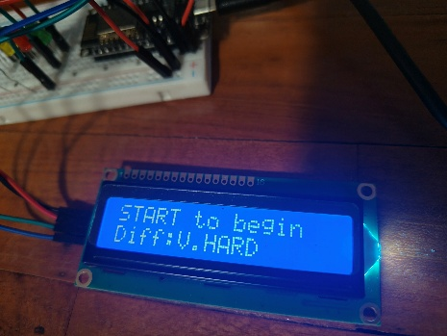
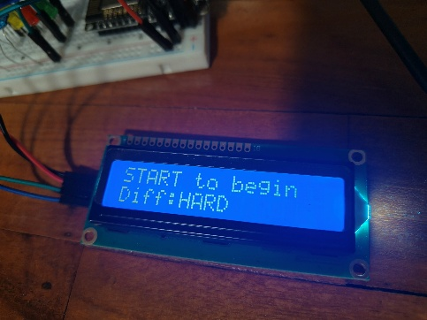

Figure 2: (Board 1) LCD Difficulty Display in Idle State
The difficulty settings can be adjusted via pressing the Blue, Yellow, Red Green buttons for Easy, Normal, Hard and Very Hard respectively.

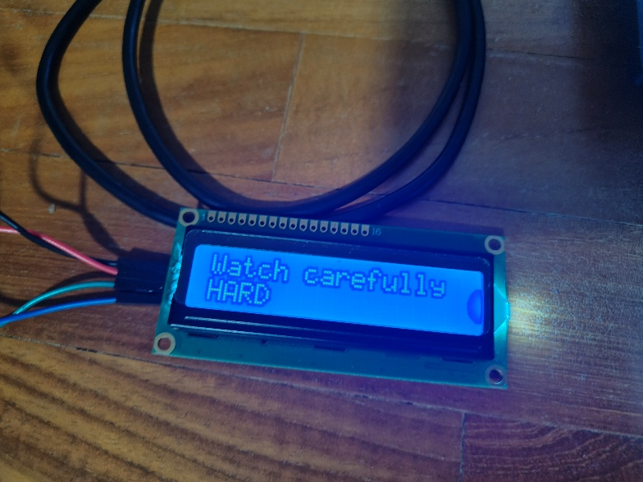

Figure 3: (board 1): Sequence State
Sequence state makes the LCD tell the user to watch the sequence play out with the LEDs currently performing playback using the LEDs in board 1.

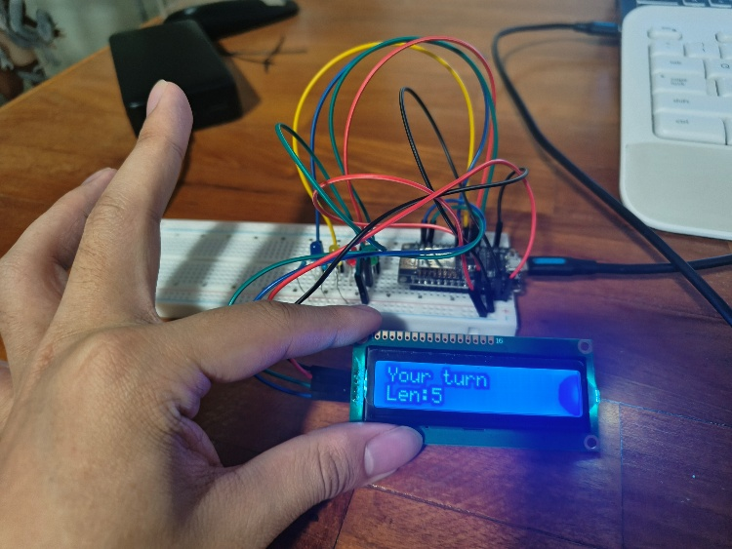

Figure 4 (board 1): User Input State
User Input state makes the LCD tell the user to input in the correct sequence using the buttons in board 2.

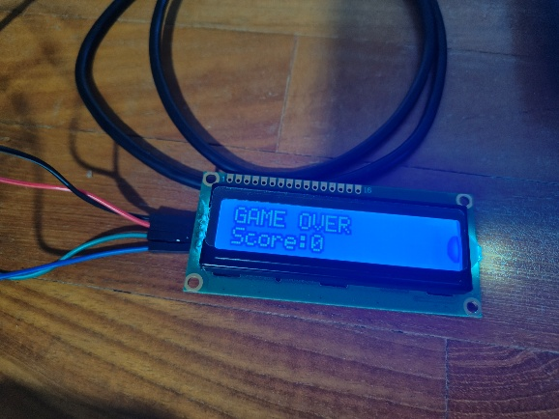

Figure 5 (board 1) Game Over State
Game Over state occurs when the user did not input in the correct sequence using the buttons in board 2. The LCD tells the player the game is now over.

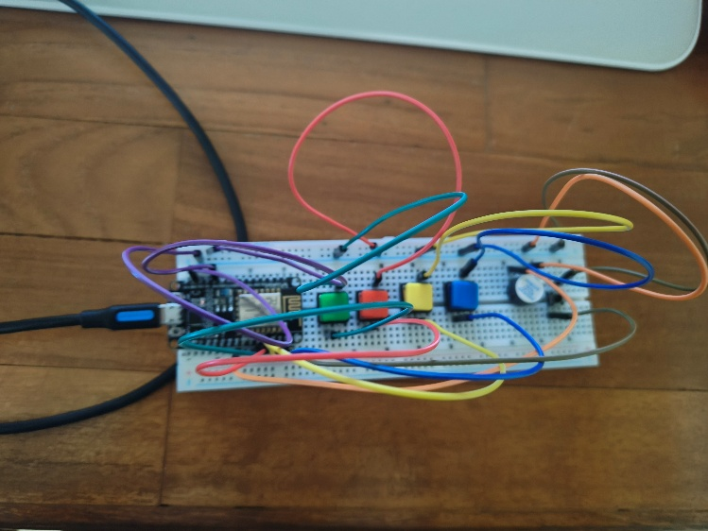
Figure 6 (board 2) Buttons and Buzzer display.
Buttons are used to communicate user input from board 2 to board 1. The buzzer activates only when the user did not input in the correct sequence.

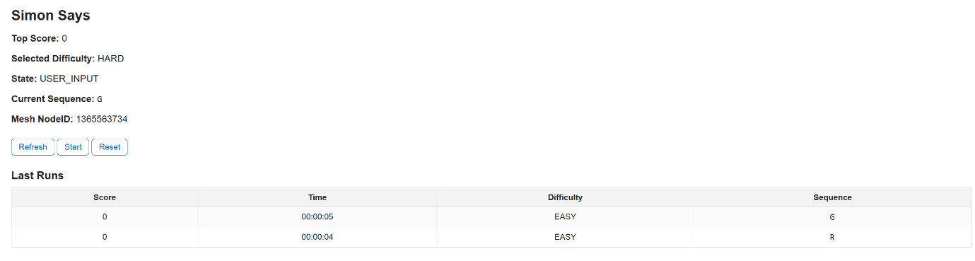
Figure 7: HTML Dashboard
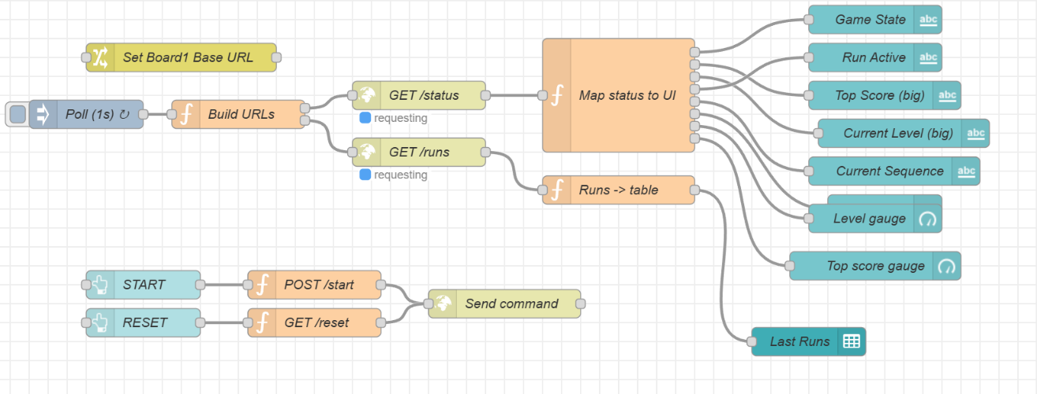
HTML dashboard displaying gameplay data including score and time taken.
Figure 8: Node Red Flow
This Node-RED flow retrieves gameplay data for display on the Node-RED Dashboard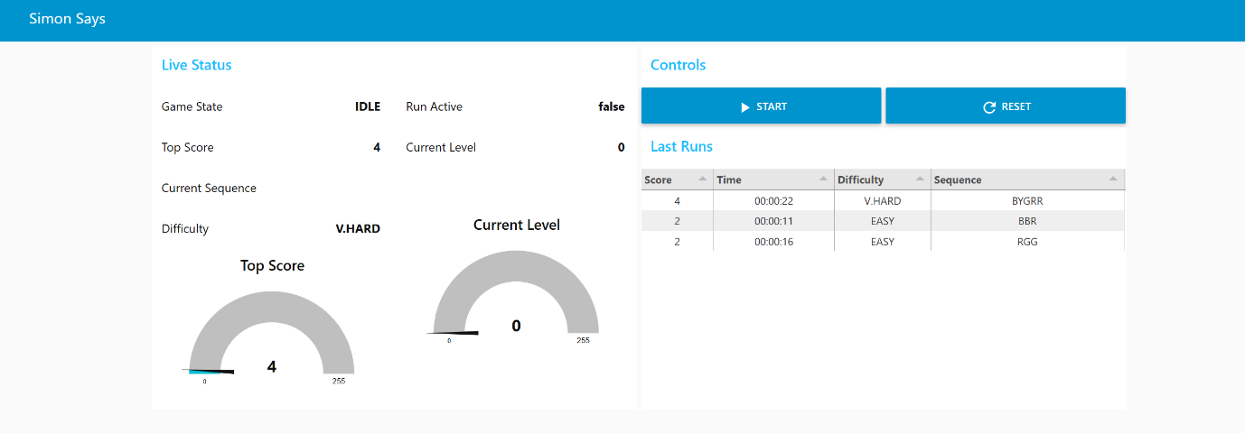Figure 9: Node Red Dashboard
The Node-RED dashboard displays gameplay data including score and time taken.

Critical analysis and reflection
The development of this IoT-based project demonstrates that physical computing can be effectively integrated with networked data systems to create an interactive cognitive learning tool. By combining tangible hardware interaction with real-time data transmission, the system moves beyond a traditional memory game and becomes a structured, data-informed platform for cognitive engagement.
The successful integration of physical components (LEDs, buttons, LCD) with IoT dashboard functionality reduces reliance on prolonged screen exposure while maintaining meaningful digital monitoring. Unlike purely screen-based applications, this approach encourages hands-on interaction and active participation. Furthermore, the implementation of both HTML and Node-RED dashboards enables session data — including score, difficulty level, and time taken — to be visualised, stored, and reviewed, enhancing transparency for caregivers or educators and allowing performance tracking across multiple sessions.
During the development of the IoT project, several challenges were encountered, particularly in the implementation of painlessMesh. Configuring painlessMesh required careful handling of node initialisation, connection stability, and message synchronisation between boards.
Despite the successful implementation of the system, it is not without limitations. The current prototype relies on local Wi-Fi infrastructure and a locally hosted Node-RED dashboard, which restricts portability and large-scale deployment. Furthermore, while the scoring system captures performance metrics such as score and time taken, it does not yet incorporate deeper analytics such as trend tracking, adaptive difficulty adjustment, or long-term performance evaluation.
Overall, this project demonstrates the feasibility of combining physical computing and IoT technologies to create an engaging and data-informative educational tool.

References:
[1] Fatima Malik; Raman Marwaha (2023). Cognitive Development. National Library of Medicine.
Available at: https://www.ncbi.nlm.nih.gov/books/NBK537095/
[2] Rebecca Baum (2018) The Power of Play: A Pediatric Role in Enhancing Development in Young Children National Library of Medicine (USA)
Available at: https://pubmed.ncbi.nlm.nih.gov/30126932/
[3] Paul Marshall (2007) Do tangible interfaces enhance learning? ACM Digital Library
Available at: https://dl.acm.org/doi/10.1145/1226969.1227004
[4] James Paul Gee (2003) What video games have to teach us about learning and literacy ACM Digital Library
Available at: https://dl.acm.org/doi/abs/10.1145/950566.950595

